**Adaptive HCI**

***Use Case Specification Document***

**Use Case ID: 1**

**Use Case Name: 3D Finger Tracking for Air Writing Recognition**

**Version No. 1**

**Project Document Revision History**

| **Version Number** | **Date** | **Revision Author** | **Description of Revision** |
| --- | --- | --- | --- |
| 1 | 10/07/2024 | Alan Diviya Raj | Original Revision |



**1. Introduction ........................................................................ 4**

**2. Use Case Information ......................................................... 4  
2.1 Actors ...................................................................................... 4  
2.2 Use Case Interaction ............................................................. 4**

**3. Trigger ................................................................................. 4  
3.1 The use case is initiated by the user starting finger movements .... 4  
3.2 The mobile app captures and processes finger movements ............ 4**

**4. Pre-condition(s) ................................................................. 4  
4.1 User is correctly positioned in front of the camera ............................ 4  
4.2 The app is running ................................................................. 4**

**5. Post-condition(s) ................................................................. 4  
5.1 3D finger path visualized in real-time .......................................... 4  
5.2 Characters sent to the system for further interaction ................... 4**

**6. Use Case Swimlane Diagram ............................................. 5**

**7. Main/Basic Flow(s) of Events (Happy Path) ....................... 6  
7.1 User forms characters with finger movements ........................... 6  
7.2 App captures and processes finger movements ........................ 6  
7.3 App reconstructs finger movements into 3D paths .................... 6  
7.4 3D paths are rendered in OpenGL ........................................ 6  
7.5 Recognized characters are displayed/sent to the system .............. 6**

**8. Alternate/Exception Flow of Events .................................. 6  
8.1 Invalid finger movement data ................................................ 6  
8.2 Unrecognized character ...................................................... 6  
8.3 Invalid positioning of finger .................................................. 6**

**9. Assumptions/Business Rules including Non-Functional Requirements 6  
9.1 Finger movements within the camera's field of view ................. 6**

**10. Use Case Specification Review and Signoff ...................... 7**

# Introduction

This use case describes how a 3D modeling application can be used for adaptive Human-Computer Interaction (HCI) techniques. The application recognizes finger movements in front of a camera to interpret writing. The application tracks the user's finger movements, reconstructs them in real-time, and interprets the resulting paths as characters or symbols. These characters can serve as input for various applications.

# Use Case Information

## Actors

| Actor Name | Description |
| --- | --- |
| User | Moves their finger in front of the camera to write a set of characters |
| Mobile App | Captures and tracks finger movements, reconstructs them as 3D models, and interprets them as writing. |
| OpenGL | Visualizes the finger paths in 3D, rendering them on the screen in real-time. |

## Use Case Interaction

* The use case is triggered when the user moves their finger in the air in front of the mobile app to form characters.
* The camera captures the finger movements, and the app reconstructs these movements into 3D models, recognizing them as characters.
* The recognized characters are displayed on the screen and sent to the target system for interaction.

# Trigger

# The use case is initiated when the user begins writing in the air in front of the mobile app.

# 3.2 The mobile app captures and processes the finger movements in real-time, reconstructing the path for character recognition.

# Pre-condition(s)

* 1. The user must be positioned correctly in front of the mobile app, with fingers within the camera’s field of view as well as within a certain distance.
  2. The app must be running during this period.

1. **Post-condition(s)**
   1. The 3D finger path is visualized on the screen in real-time.
   2. The recognized characters are sent to the system for further interaction.

# Use Case Swimlane Diagram

**6.1**

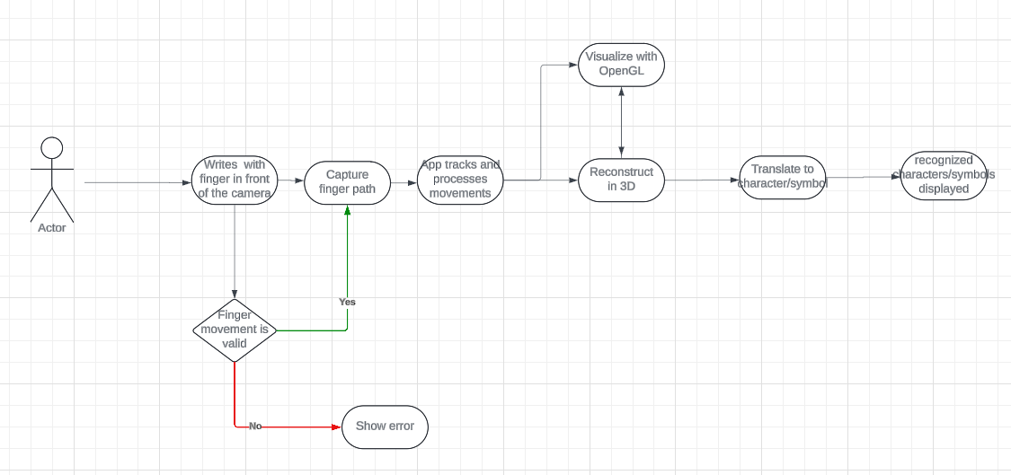

**6.2**

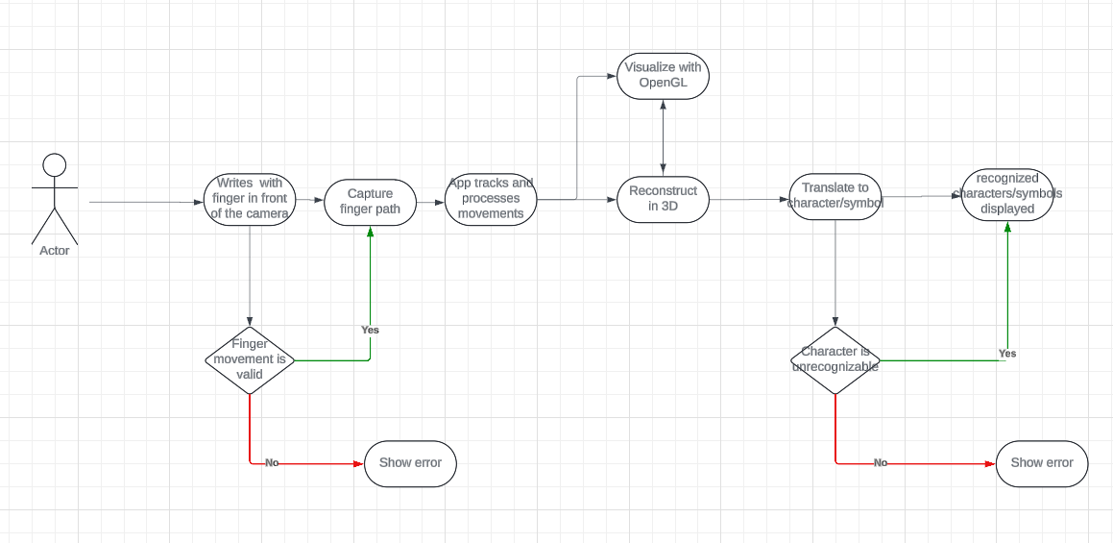

# Main/Basic Flow(s) of Events (Happy Path)

# The user moves their finger in the air, forming characters.

# The mobile app captures the finger movement data.

# The app reconstructs the finger movements into 3D paths using real-time modeling.

# The app sends the 3D path data to OpenGL.

# OpenGL renders the 3D finger paths on the screen.

# The app interprets the finger path as a character or symbol.

# 7.7 The recognized character is sent to the text system for display or further

# interaction.

# 8. Alternate/Exception Flow of Events

# 8.1 Invalid Finger Movement Data

# If the captured finger movement data is incomplete or incorrect, an error message is displayed, and no rendering occurs.

# 8.2 Unrecognized Character

# If the app does not recognize the finger path as a valid character, no input is sent to the text system, and a notification is displayed.

# 8.3 Invalid positioning of finger

# If the hand/finger is not positioned properly in front of the camera, the app cannot read the information properly, and an error message is displayed

# 9. Assumptions/Business Rules including Non-Functional Requirements

# 9.1 The user’s finger movements must be within the camera’s field of view for accurate tracking and recognition.

# 10. Use Case Specification Review and Signoff

| Review and Signoff of the Use Case Specification | | | |
| --- | --- | --- | --- |
| Name | Project Team Role | Signature | Date |
| Soham Naik | Lead Image Processing & Computer Vision Engineer | [Soham Naik](mailto:sohamn@umich.edu) | 10/16/2024 |
| Deniz Acikbas | Lead Mobile App & VR/AR Engineer | [Deniz Acikbas](mailto:dacikbas@umich.edu) | 10/16/2024 |
| Zaynab Mourtada | Lead Machine Learning Engineer | [Zaynab Mourtada](mailto:zaynabmo@umich.edu) | 10/16/2024 |
| Alan Raj | Lead 3D Visualizer Engineer | [Alan Raj](mailto:alanraj@umich.edu) | 10/16/2024 |
| Xiao Zhang | Client |  | 10/16/2024 |